- List all employee IDs and birth dates of employees who were born before 1965.
SELECT e_id, birth_date
FROM employee_per
WHERE birth_date < '1965-01-01';
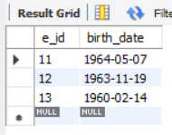
- Display IDs and birth dates of employees born in and between 1970 and 1972.
SELECT e_id, birth_date
FROM employee_per
WHERE birth_date BETWEEN '1970-01-01' AND '1972-12-31';
